

NOVAC TECHNOLOGY SOLUTIONS

User Manual

Document Version No.: 1.00

Revision History
Version No | Reason For Changes | Author | Approver
0.01 | Draft | VINOTHINI S
1.00 | Reviewed & Approved the User Manual | VINOTHINI S | NIJANTHAN PL

Table of Contents
1. Introduction 4
2. Changes in UW Distribution 4

Introduction

This user manual explains about changes incorporated in UW Distribution for all Non-Motor products in ZIVA Philippines Module.

Changes in UW Distribution

- System is expected to edit the UW Distribution share amount values in the proposal screen after auto-defaulting UW distribution details in the block for Non-Motor products.
- System should allow users to modify the UW distribution fields, which is highlighted below.
- The system is required to validate and ensure that sum of modified share amount should be equal to the total sum insured against each location. If the modified value exceeds or less than the total sum insured, the system should generate an error message stating, "UW distribution value is not tally – respective Location ID."
- System should auto-calculate and update the share % values in the respective fields based on the modified share amount.

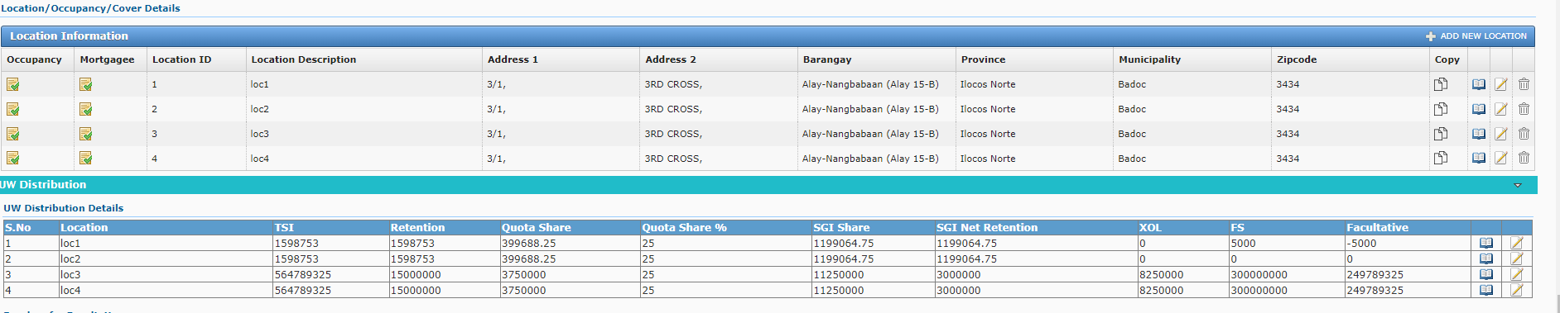
By clicking the edit icon user can modify the UW Distribution values. On clicking the edit icon, system display the UW Distribution screen.

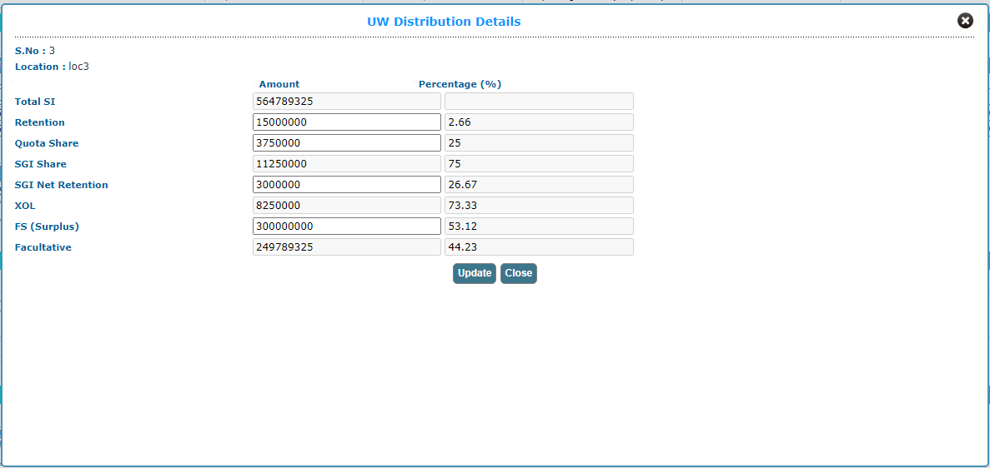
After modify the UW Distribution values, click on Update button.

